**Multipurpose Agriculture Vehicle**

**ABSTRACT**

Agriculture has been the backbone of the economy and it will continue to remain. Agriculture is the science and art of farming including cultivating the soil, producing crops and raising livestock. Generally, cultivation of any crop involves various steps like ploughing, harvesting, sowing, and irrigation. Farmer has to use various agricultural equipment’s and labours for caring out these steps, our purpose is to combine all the individual tools to provide farmers with multipurpose equipment which implements all the scientific farming techniques and specifications, suitable for all type of seed to seed cultivation with minimum cost as possible. All this can be done in this same machine. This multipurpose agro machine is wireless remote operated & designed and fabricated as a multipurpose equipment which is used for agricultural processes like ploughing, sowing seeds and sprinkling water. This machine works in both directions when it is pushed forward it ploughs the field with the help of plough. The height of the plough can be adjusted, with the help of screw arrangement and the seed feeder is mounted directly to the motor. The motor rotates and the shaft attached to it has holes. The motor is directly attached to the shaft with holes. When we push the agriculture machine in a backward direction, we can pick the plough up from the ground and the pump which is attached to the front shaft will start pumping the water from the tank and it will sprinkle water over the field.

**Literature Review**

In agriculture the use of robots enhances the productivity and reduces the human effort and cost. The automation of various agricultural activities by robots are envisioned. It has been described that the present robot can perform better and can automate more than one work simultaneously. This robot can be effectively used by the farmers.

In future this robot can be enhanced with some more cognitive capabilities and also to take appropriate actions even in the absence of the farmers. It can be induced with human interaction and also learning from experience, given by Blackmore, S.(2007). “A systems view of agricultural robotics”.

Central to this idea was the proposal of the implementation of the PFDS and PADS, and their strong interaction. The PFDS is primarily used for relaying spatial accuracy information for machinery navigation, while the PADS are used to communicate the agronomy information about, and requirements of, the crop, given by R. Eaton, R. Eaton, J. Katupitiya, S D Pathirana (2008), “Autonomous farming: Modeling and control of agricultural machinery in a unified framework”.

Gowtham kumar S N, Multipurpose Agriculture Machine. The paper presents about the multiple agricultural tasks done by the single robot. To develop the efficiency of the agricultural tasks we have to find the new ways. This project deals with a novel approach for cultivating lands in very efficient way. The distinctiveness of this agriculture robot system is it is multitasking abilities which can drill, pick and place, seeding, pumping water & fertilizers, weather monitoring to work in both agriculture, afforestation and gardening platform.

Vishnu Prakash K, Design and Fabrication of Multipurpose Agricultural Robot, -This paper presents a project developed at the K.S.Rangasamy College of Technology ( Tamilnadu, India) aimed at designing, implementing, and testing an autonomous multipurpose vehicle with safe, efficient, and economic operation. This autonomous vehicle moves through the crop lines of a Agricultural land and performs tasks that are tedious and/or hazardous to the farmers. First, it has been equipped for spraying, but other configurations have also been designed, such as: a seeding ,plug platform to reach the top part of the plants to perform different tasks (pruning, harvesting, etc.), and a trailer to transport the fruits, plants, and crop waste.

B S Balaji, Smart Phone Operated Multipurpose Agricultural Robot, The paper aims on the design, development and the fabrication of the robot which can dig the soil, leveler to close the mud and sprayer to spray water, these whole systems of the robot works with the battery and the solar power. More than 40% of the population in the world chooses agriculture as the primary occupation, in recent years the development of the autonomous vehicles in the agriculture has experienced increased interest.

**Introduction**

Agriculture has been the backbone of the Indian economy and it will continue to remain so for a long time. ―A man without food for three days will quarrel, for a week will fight and for a month or so will die‖. Agriculture is a branch of applied science. Agriculture is the science and art of farming including cultivating the soil, producing crops and raising livestock. It is the most important enterprise in the world. Over the years, agricultural practices have been carried out by small-holders cultivating between 2 to 3 hectare, using human labor and traditional tools such as wooden plough, yoke, leveler, harrow, mallot, spade, big sikle etc. These tools are used in land preparation, for sowing of seeds, weeding and harvesting.

Modem agricultural techniques and equipments are not used by small land holders because these equipments are too expensive and difficult to acquire. By adopting scientific farming methods we can get maximum yield and good quality crops which can save a farmer from going bankrupt but majority of farmers still uses primitive method of farming techniques due to lack of knowledge or lack of investment for utilizing modern equipment.

The use of hand tools for land cultivation is still predominant in India because tractors require resources that many Indian farmers do not have easy access to. The need for agricultural mechanization in India must therefore be assessed with a deeper understanding of the small holder farmer‘s activities. There is huge gap in technology adoption and Implement used with small and marginal farmers. Sustainable improvement in the livelihoods of poor farmers in developing countries depends largely on the adoption of improved resource conserving cropping systems. While most of the necessary components already exist, information on the availability and performance of equipment is lacking and effective communication between farmers and agricultural research and development department is unsuccessful.

**Main Features of Indian Agriculture**

(i) Source of livelihood:

Agriculture is the main occupation. It provides employment to nearly 61% persons of total population. It contributes 25% to national income.

(ii) Dependence on monsoon:

Agriculture in India mainly depends on monsoon. If monsoon is good, the production will be more and if monsoon is less than average then the crops fail. As irrigation facilities are quite inadequate, the agriculture depends on monsoon.

(iii) Labor intensive cultivation:

Due to increase in population the pressure on land holding increased. Land holdings get fragmented and subdivided and become uneconomical. Machinery and equipment cannot be used on such farms.

(iv) Under employment:

Due to inadequate irrigation facilities and uncertain rainfall, the production of agriculture is less; farmers find work a few months in the year. Their capacity of work cannot be properly utilized. In agriculture there is under employment as well as disguised unemployment.

(v) Small size of holdings:

Due to large scale sub-division and fragmentation of holdings, land holding size is quite small. Average size of land holding was 2 to 3 hectares in India while in Australia it was 1993 hectares and in USA it was 158 hectares.

(vi) Traditional methods of production:

In India methods of production of crops along with equipment are traditional. It is due to

poverty and illiteracy of people. Traditional technology is the main cause of low production.

(vii) Low Agricultural production:

Agricultural production is low in India. India produces 27 Qtls Wheat per hectare. France produces 71.2 Qtls per hectare and Britain 80 Qtls per hectare. Average annual productivity of an agricultural labour is 162 dollars in India, 973 dollars in Norway and 2408 dollars in USA.

(viii) Dominance of food crops:

75% of the cultivated area is under food crops like Wheat, Rice and Bajra, while 25% of cultivated area is under commercial crops. This pattern is cause of backward agriculture.

**Major Challenges Faced By Indian Agriculture**

1. Stagnation in Production of Major Crops: Production of some of the major staple food crops like rice and wheat has been stagnating for quite some time. This is a situation which is worrying our agricultural scientists, planners and policy makers. If this trend continues, there would be a huge gap between the demand of ever growing population and the production.

2. High cost of Farm Inputs: Over the years rates of farm inputs have increased. Farm inputs include fertilizer, insecticide, pesticides, HYV seeds, farm labour cost etc. Such an increase puts low and medium land holding farmers at a disadvantage.

3. Soil Exhaustion: Soil exhaustion means loss of nutrients in the soil from farming the same crop over and over again. This usually happens in the rain forest.

4. Depletion of Fresh Ground Water: Most of the irrigation in dry areas of Punjab,

Haryana and Western Uttar Pradesh was carried out by excessive use of ground water. Today fresh ground water situation in these states is alarming. In the coming few years if this type of farming practice continues, these states are going to face water famine.

5. Adverse impact of Global Climatic Change: Among various challenges, global climatic change is the recent one. It is predicted that due to climate change, temperature

would increase from 2°C to 3°C, there would be increase in sea level, more intense cyclones, unpredictable rainfall etc These changes would adversely affect the production of crops.

6. Impact of Globalization: You can see the effect of globalization on the farm sector in India. All developing countries have been affected by it. The most evident effect is the squeeze on farmer‘s income and the threat to the viability of cultivation in India. This is due to the rising input costs and falling output prices. This reflects the combination of reduced subsidy and protection to farmers.

7. Providing Food Security: Before the introduction of green revolution in India, we were not self sufficient in terms of our food grain production. With the introduction of green revolution, production of food grains increased substantially and India became self sufficient. However, during the last one decade the total production has become stagnant.

On the other hand we have added another 16 to 18 million populations over this period. Although India has become self sufficient in good it is yet to ensure food security which is dependent upon accessibility, affordability as well nutritional value of the food available. One of the biggest challenges facing India is Providing Food Security to its population.

8. Farmers Suicide: Every suicide has a multiple of causes but when you have nearly 200,000 of them, it makes sense to seek broad common factors within that group. The suicides appear concentrated in regions of high commercialization of agriculture and very high peasant debt. Cash crop farmers seemed far more vulnerable to suicide than those growing food crops. Yet the basic underlying causes of the crisis remained untouched. Commercialization of the countryside along with massive decline in investment in agriculture was the beginning of the decline. Withdrawal of bank credit at a time of soaring input prices and the crash in farm incomes compounded the problems. Shifting of millions from food crop to cash crop cultivation had its own risks. Privatization of many resources has also compounded the problems. The devastation lies in the big 5 States of

Maharashtra, Andhra Pradesh, Karnataka, Madhya Pradesh and Chhattisgarh. These states accounted for two-thirds of all farm suicides during 2003-08.Some of the major factors responsible are indebtedness, crop failure and deterioration in economic status. Decline in social position, exorbitant charges by local money lenders for the vulnerable farmers, chronic illness in the family, addiction etc. have made life of farmers difficult.

**Advantages of Tractor Powered Equipment**

Time consumption is very less.

Operation is easy.

Most suitable for larger fields.

**Disadvantages of Tractor**

Costly, High initial cost (6 to 8 lakh), high maintenance cost (diesel cost) and service costfor replacing and repairs of the parts.

Tractor wheels will destroy furrows. An average weight of tractor is around 2 tons, when its weight acts on soil it tends to form a clods these clods prevents the root growth.

Produces large amount of clods, hence clod breaker has to be used.

Tractors are not enough flexible for variations like edge tilling and corner furrowing.

Requires skilled person. The handling of tractor in an agricultural field is comparativelybdifficult than conventional technique.

Once the crop is germinated tractor has no further use in cultivation process.

Disadvantages of Bullock Powered Equipment.

Consume more time.

Difficult to cultivate large areas.

Advantages Of Bullock Powered Equipment

Low cost.

Suitable for all types of agricultural operations.

Flexible to changes; the irregular paths can be created according to requirements of theformer.

The seeds and the furrows will not be damaged as seen in tractors.

**AGRICULTURE**

**Introduction**

Agriculture is the art and underlying science in production and improvement of field crops with the efficient use of soil fertility, water, labor and other factors related to crop production. It is the most important enterprise in the world. About 70% of Indian populations are either farmers or involved in some agricultural related activities

**Steps Involved In Agriculture**

a. Seed selection

Among varieties of crops, a suitable crop has to be selected for cultivation.

b. Land preparation

It involves tilling, ploughing and furrows and ridges formation

c. Fertilizer application: organic fertilizer is applied during ploughing, chemical fertilizer is applied before sowing and during vegetative stage.

d. Seed preparation

Seeds are treated with fungicides like carbendazim before sowing.

e. Sowing

Seeding or sowing is an art of placing seeds in the soil to have good germination in the field

f. Irrigation

Watering the crops for its growth and development.

- Surface irrigation.

- Drip irrigation.

- Sprinkler irrigation.

- Rain dependent irrigation.

g. Germination – seed develops into a two leaf stage, tiny plant.

h. Thinning – only one plant is retained in each pit by plucking the excess seeding. One healthy seeding is left and other seeding is plucked to support the complete resources of water, fertilizer and spacing for single plant.

i. Filling – if there is no germination in some pits; when some seeds fail to germinate, then seedling is plucked from where it is excess and planted at the empty space.

j. Weeding: The process of removing the unwanted plants in the field to ensure complete utilization of resources only to the crop.

- Manual weeding (once in 3 weeks).

- Before sowing, field has to be ploughed well to remove all weeds.

- After germination tiny weeds area removed using weeding blade.

- After vegetative stage weedicides are sprayed. Chemical weeding – spraying of weedicides like "pendimethalin" of 1 liter is mixed with 200 liters of water for one hectare. Spraying during weeding will prevent formation of weeds during next one month.

k. Vegetative stage – maximum growth of plant takes place in this stage.

l. Flowering stage: plant starts producing flowers in this stage.

m. Pesticides spraying – When the crops are infested with pests use pesticides.

n. Fruit/pod formation stage: At this stage development of fruit or pod takes place.

o. Harvesting stage – separating crop from soil.

p. Threshing – separating seeds from plants.

**Sowing**

Seeding or sowing is an art of placing seeds in the soil to have good germination in the field. A perfect seeding gives

a. Correct amount of seed per unit area.

b. Correct depth at which seed is placed in the soil.

c. Correct spacing between row-to-row and plant-to-plant.

**Methods of Sowing:**

The sowing method is determined by the crop to be sown. There are 6 sowing methods which differ in their merits, demerits and adoption. Those are:

**1) Broad casting:** It is the scattering of seeds by hand all over the prepared field followed by covering with wooden plank or harrow for contact of seed with soil. Crops like wheat, paddy, Sesamum, methi, coriander, etc. are sown by this method.

**Advantages:**

(a) Quickest & cheapest method

(b) Skilled labor is not required.

(c) Implement is not required.

(d) Followed in moist condition.

**Disadvantages:**

(a) Seed requirement is more.

(b) Crop is not uniform.

(c) Results in gap in germination & defective wherever the adequate moisture is not present in the soil.

(d) Spacing is not maintained within rows & lines, hence interculturing is difficult.

**2) Drilling or Line sowing:** It is the dropping of seeds into the soil with the help of implement such as mogha, seed drill, seed-cum-ferti driller or mechanical seed drill and then the seeds are covered by wooden plank or harrow to have contact between seed & soil. Crops like Jowar, wheat Bajara, etc. are sown by this method.

**Advantages:**

(a) Seeds are placed at proper & uniform depths

(b) Along the rows, interculturing can be done

(c) Uniform row to row spacing is maintained

(d) Seed requirement is less than ‗broad casting‘

(e) Sowing is done at proper moisture level.

**Disadvantages:**

a) Require implement for sowing

b) Plant to plant (Intra row) spacing is not maintained

c) Skilled person is required for sowing.

**3) Dibbling:** It is the placing or dibbling of seeds at cross marks (+) made in the field with the help of maker as per the requirement of the crop in both the directions. It is done manually by dibbler. This method is followed in crops like Groundnut, Castor, Cotton, etc. which are having bold size and high value.

**Advantages:**

a) Spacing between rows & plants is maintained

b) Seeds can be dibbled at desired depth in the moisture zone

c) Optimum plant population can be maintained

d) Seed requirement is less than other method

e) Implement is not required for sowing

f) An intercrop can be taken in wider spaced crops

g) Cross wise Intercultivation is possible

**Disadvantages:**

a) Laborious & time consuming method

b) Require more labour, hence increase the cost of cultivation

c) Only high value & bold seeds are sown

d) Require strict supervision.

**4) Transplanting:** It is the raising of seedlings on nursery beds and transplanting of seedlings in the laid out field. For this, seedlings are allowed to grow on nursery beds for about 3-5 weeks. Beds are watered one day before the transplanting of nursery to prevent jerk to the roots. The field is irrigated before actual transplanting to get the seedlings established early & quickly which reduce the mortality. Besides the advantages & disadvantages of dibbling method, initial cost of cultivation of crop can be saved but requires due care in the nursery. This method is followed in crops like paddy, fruit, vegetable, crops, tobacco, etc.

**5) Planting:** It is the placing of vegetative part of crops which are vegetatively propagated in the laid out field. E.g.: Tubers of Potato, mother sets of ginger & turmeric, cuttings of sweet potato & grapes, sets of sugarcane.

**6) Sowing behind the plough:** Sowing behind the plough is done by manual or mechanical means. Seeds are dropped in the furrows opened by the plough and the same is closed or covered when the next furrow is opened. The seeds are sown at uniform distance. Manual method is a laborious and time consuming process. Seeds like redgram, cowpea and groundnut are sown behind the country plough. Major sown crop is ground out. Seeds are sown by mechanical means by Gorus – seed drill. A seed drill has a plough share and hopper. Seeds are placed on hopper. Currently different types of seed drill are available.

**7) Some other forms of sowing are:**

Row planting: Mark the placement of a row within your garden, and then make a furrow at the correct depth along the row. Some seeds may not sprout, so sow seeds more thickly than you want the final spacing of the crops to be. Thinning rows is less of a chore if you space seeds as evenly as possible. Cover the seeds with fine soil and then firm them in with the back of a hoe to make sure that all the seeds are in contact with the soil. Water gently. If you plan to use furrow irrigation, fill the furrows with water first and then push the large seeds into the top of raised beds.

Wide row planting: This method allows you to plant more seeds in less space by concentrating watering, weeding, and fertilizing in a smaller area. Rows are generally

10 to 16 inches (25 to 41 cm) wide. Sprinkle seeds over the entire row — with most crops, try to land the seeds about 1/2 to 1 inch (1 to 2 cm) apart. For peas and beans, space them 1-1/2 to 2 inches (4 to 5 cm). Cover small seeds with a thin layer of potting soil. Lightly pat the potting soil down again to bring the added soil into firm contact with the seeds.

Bed planting: Planting in beds is essentially the same as planting wide rows.

Hill planting: Plant seeds for vining crops that spread out, such as squash, melons, or cucumbers, in hills or circular groups. Loosen the soil in a 1-foot-diameter (30 cm) area, level the area, and then plant five to six seeds close together. Thin out all but the two strongest seedlings

**Factors affecting Germination and Emergence:**

* Viability of seed
* Soil temperature
* Availability of soil moisture to seeds
* Soil aeration
* Mechanical impedance of seedling emergence (resistance of soil to penetration by seedling)

These are influenced by:

* Soil type
* Physical condition of the soil
* Depth of planting
* Intimacy of contact between seeds and soil
* Degree of compacting of soil above the seeds
* Formation of surface crusts after planting
* Final field stand is also due to disease, insects, and adverse environmental conditions.

Design Consideration

Several structural design considerations should be taken into account for economical and efficient manufacturing. Many of these apply to other joining methods, and all apply to both subassemblies and the complete structure.

DESIGN PROCEDURE

1. Definition of problem

2. Synthesis

3. Analysis of forces

4. Selection of material

5. Determination of mode of failure

6. Selection of factor of safety

7. Determination of dimensions

8. Modification of dimensions

9. Preparation of drawings

10. Preparation of design report

DESIGN CONSIDERATIONS

* Strength
* Rigidity
* Reliability
* Safety
* Cost
* Weight
* Ergonomics
* Aesthetics
* Manufacturing considerations
* Assembly considerations
* Conformance to standards
* Friction and wear
* Life
* Vibrations
* Thermal considerations
* Lubrication
* Maintenance
* Flexibility
* Size and shape
* Stiffness
* Corrosion
* Noise
* Environmental considerations

AESTHETIC CONSIDERATIONS IN DESIGN

• Appearance is an outward expression of quality of the product and is the first communication of product with the user.

• Aesthetics is defined as the set of principles of appreciation of beauty. It deals with the appearance of the product.

ASPECTS OF AESTHETIC DESIGN

* Form(shape)
* Symmetry and shape
* Color
* Continuity
* Variety
* Proportion
* Noise
* Contrast
* Impression and purpose
* Style
* Material and surface finish
* Tolerance

ERGONOMICS CONSIDERATIONS IN DESIGN

• Ergonomics is defined as the study of the man - machine - working environment relationship

• It aims at decreasing the physical and mental stresses to the user

• Areas covered under ergonomics

• Communication between man (user) and machine

• Working environment

• Human anatomy and posture while using the machine

• Energy expenditure in hand and foot operations

MANUFACTURING CONSIDERATIONS IN DESIGN

* Minimum total number of parts in a product
* Minimum variety of parts
* Use standard parts
* Use modular design
* Design parts to be multifunctional
* Design parts for multiple use
* Select least costly material
* Design parts for ease of manufacture
* Shape the parts for minimizing the operations

STANDARDIZATION

• It is the process of establishing the set of norms to which a specified set of characteristics of a component or a product should conform

• Example: Standardizing the shaft consists of specifying the set of shaft diameters and material

**Objectives of standardization**

• To make the interchangeability of the components possible

• To make the mass production of components easier

MECHANICAL PROPERTIES OF MATERIALS

* Strength
* Stiffness/Rigidity
* Elasticity
* Plasticity
* Ductility
* Brittleness
* Malleability
* Toughness
* Machinability
* Resilience
* Creep
* Fatigue
* Hardness

**DESIGN AND FABRICATION OF MULTIPURPOSE**

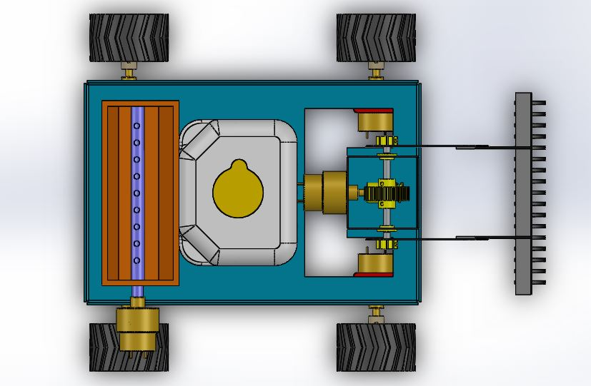

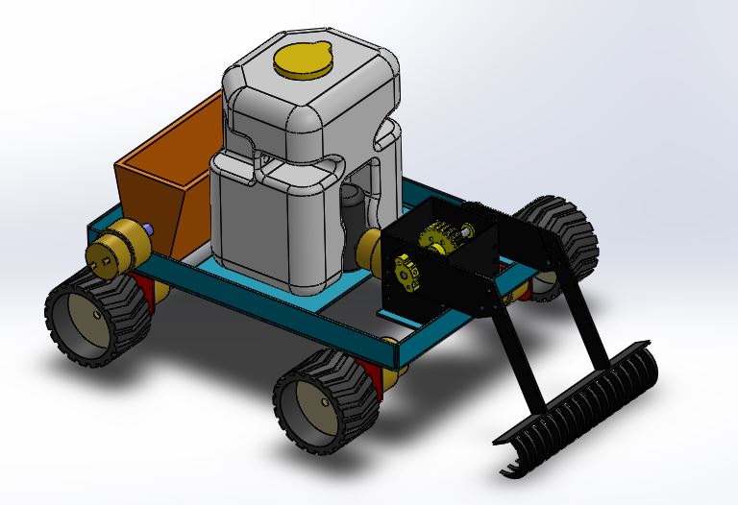

**Components**

* Plougher – Mild Steel
* Water tank
* Water Pump – 12V DC
* Seed feeder
* Wheels
* Motors
* Metal frame

**Fabrication Processes used**

**Laser Beam Machining (LBM)**

Lasers are used for many purposes. One way they are used is for cutting metal plates. On mild steel, stainless steel, and aluminum plate, the laser cutting process is highly accurate, yields excellent cut quality, has a very small kerf width and small heat affect zone, and makes it possible to cut very intricate shapes and small holes.

Most people already know that the word “LASER” is actually an acronym for Light Amplification by Stimulated Emission of Radiation.

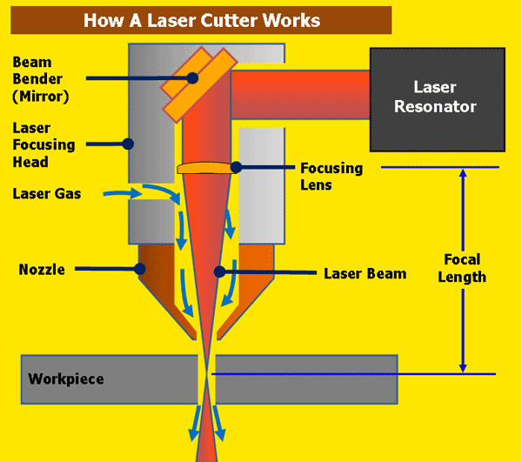

The laser beam is a column of very high intensity light, of a single wavelength, or color. In the case of a typical CO2 laser, that wavelength is in the Infra-Red part of the light spectrum, so it is invisible to the human eye. The beam is only about 3/4 of an inch in diameter as it travels from the laser resonator, which creates the beam, through the machine’s beam path. It may be bounced in different directions by a number of mirrors, or “beam benders”, before it is finally focused onto the plate. The focused laser beam goes through the bore of a nozzle right before it hits the plate. Also flowing through that nozzle bore is a compressed gas, such as Oxygen or Nitrogen.

Focusing the laser beam can be done by a special lens, or by a curved mirror, and this takes place in the laser cutting head. The beam has to be precisely focused so that the shape of the focus spot and the density of the energy in that spot are perfectly round and consistent, and centered in the nozzle. By focusing the large beam down to a single pinpoint, the heat density at that spot is extreme. Think about using a magnifying glass to focus the sun’s rays onto a leaf, and how that can start a fire. Now think about focusing 6 KWatts of energy into a single spot, and you can imagine how hot that spot will get.

The high power density results in rapid heating, melting and partial or complete vaporizing of the material. When cutting mild steel, the heat of the laser beam is enough to start a typical “oxy-fuel” burning process, and the laser cutting gas will be pure oxygen, just like an oxy-fuel torch. When cutting stainless steel or aluminum, the laser beam simply melts the material, and high pressure nitrogen is used to blow the molten metal out of the kerf.

On a CNC laser cutter, the laser cutting head is moved over the metal plate in the shape of the desired part, thus cutting the part out of the plate. A capacitive height control system maintains a very accurate distance between the end of the nozzle and the plate that is being cut. This distance is important, because it determines where the focal point is relative to the surface of the plate. Cut quality can be affected by raising or lowering the focal point from just above the surface of the plate, at the surface, or just below the surface.

There are many, many other parameters that affect cut quality as well, but when all are controlled properly, laser cutting is a stable, reliable, and very accurate cutting process.

**Advantages of LBM:**

* Tool wear and breakage are not encountered.
* Very small holes with large aspect ratio can be achieved.
* A wide variety of hard and difficult-to-machine materials can be tackled.
* Machining is extremely rapid and the setup times is economical.
* Holes can be located accurately by using an optical laser system for alignment.
* The operating cost is low.

**Lathe Machine Operations:**

**Facing**

Facing is the operation of machining the ends of a piece of work to produce flat surface square with the axis. The operation involves feeding the tool perpendicular to the axis of rotation of the work.

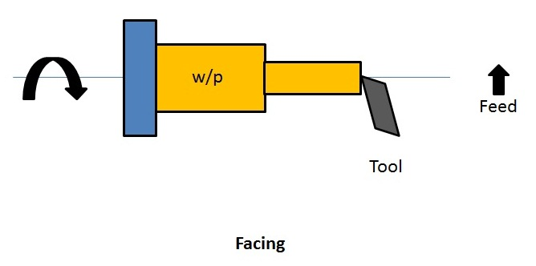

**Turning**

Turning in a lathe is to remove excess material from the workpiece to produce a cylindrical surface of required shape and size.

* **Straight turning:**The work is turned straight when it is made to rotate about the lathe axis and the tool is fed parallel to the lathe axis. The straight turning produces a cylindrical surface by removing excess metal from the workpieces.

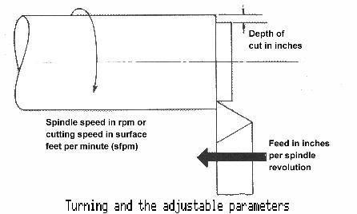

* **Step turning:** Step turning is the process of turning different surfaces having different diameters. The work is held between centres and the tool is moved parallel to the axis of the lathe. It is also called shoulder turning.

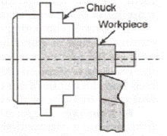

**Eccentric turning**

If a cylindrical workpiece has two separate axes of rotating, one being out of centre to the other, the workpiece is termed as eccentric and turning of different surfaces of the workpiece is known as eccentric turning. The distance between the axes is known as offset. Eccentric turning may also be done on some special machines. If the offset distance is more, the work is held by means of special centres. If the offset between the centres is small, two sets of centres are marked on the faces of the work. The work is held and rotated between each set of centres to machine the eccentric surfaces.

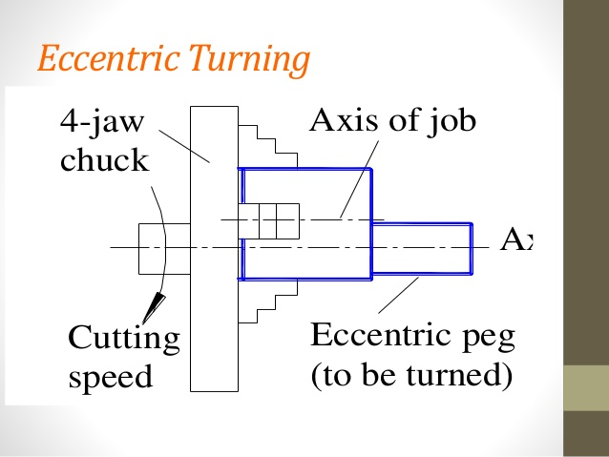

**Taper turning**

**Taper**

A taper may be defined as a uniform increase or decrease in diameter of a piece of work measured along its length.

Taper turning methods

1. Form tool method
2. Compound rest method
3. Tailstock set over method
4. Taper turning attachment method
5. Combined feed method
6. **Form tool method**

A broad nose tool is ground to the required length and angle. It is set on the work by providing feed to the cross-slide. When the tool is fed into the work at right angles to the lathe axis, a tapered surface is generated.

This method is limited to turn short lengths of taper only. The length of the taper is shorter than the length of the cutting edge. Less feed is given as the entire cutting edge will be in contact with the work.

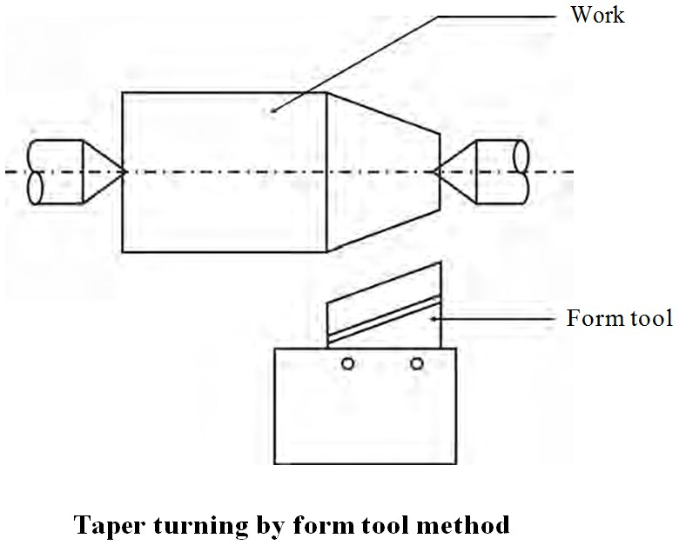

1. **Compound rest method**

The compound rest of the lathe is attached to a circular base graduated in degrees, which may be swiveled and clamped at any desired angle. The angle of taper is calculated using the formula

$$\tan{α}= \frac{D_{1}-D_{2}}{2l}$$

Where,

$$D_{1}\& D_{2}=large and small dia. respectively$$

$$l=length of taper$$

$$α=taper angle or the angle about which compound rest is swiveled$$

The compound rest is swiveled to the angle calculated as above and clamped. Feed is given to the compound slide to generate the required taper.

1. **Tailstock setover method**

Turning taper by the setover method is done by shifting the axis of rotation of the workpiece at an angle to the lathe axis and feeding the tool parallel to the lathe axis. The construction of tailstock is designed to have two parts namely the base and the body. The base is fitted on the bed guideways and the body having the dead centre can be moved at cross to shift the lathe axis.

The amount of setover – S, can be calculated as follows

$$S=L×\frac{D_{1}-D_{2}}{2l}$$

The dead centre is suitably shifted from its original position to the calculated distance. The work is held between centres and longitudinal feed is given by the carriage to generate the taper.

The advantage of this method is that the taper can be turned to the entire length of the work. Taper threads can also be cut by this method.

The amount of setover being limited, this method is suitable for turning small tapers (approx. upto 8°). Internal tapers cannot be done by this method.

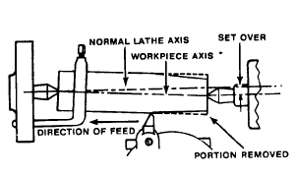

1. **Taper attachment method**

The taper attachment consists of a bracket which is attached to the rear end of the lathe bed. It supports a guide bar pivoted at the centre. The bar having graduation in degrees may be swiveled on either side of the zero graduation and set at the desired angle to the lathe axis. A guide block is mounted on the guide bar and slides on it. The cross slide is made free from its screw by removing the binder screw. The rear end of the cross slide is tightened with the guide block by means of a bolt. When the longitudinal feed is engaged, the tool mounted on the cross slide will follow the angular path as the guide block will slide on the guide bar set at an angle of the lathe axis. The depth of cut is provided by the compound slide which is set parallel to the cross-slide.

The advantage of this method is that long tapers can be machined. As power feed can be employed, the work is completed at a shorter time. The disadvantage of this method is that internal tapers cannot be machined.

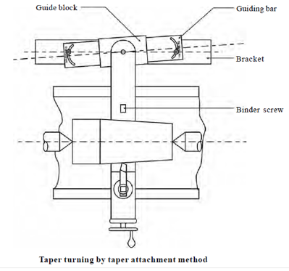

1. **Combined feed method**

Feed is given to the tool by the carriage and the cross-slide at the same time to move the tool at resultant direction to turn tapers.

**Drilling operation:**

It is the process of producing cylindrical hole in the workpiece. In this operation, Workpiece is held in a chuck or a suitable device and the drill is held in the tailstock. During operation, the drill is fed by rotating the handwheel of the tailstockin clockwise direction. First a shorter length is drilled by using a smaller and shorter drill, followed by producing the required diameter with the help of correct drill size.



**Reaming Operation**

It is a finishing operation because a very small amount of material is removed during the operation. For performing reaming a multi-teeth tool is used, which is called as reamer. During the operation, the workpiece is held in a chuck or face plate and the reamer shank is fitted in a sleeve or inserted in the tapered hole of the tailstock spindle.

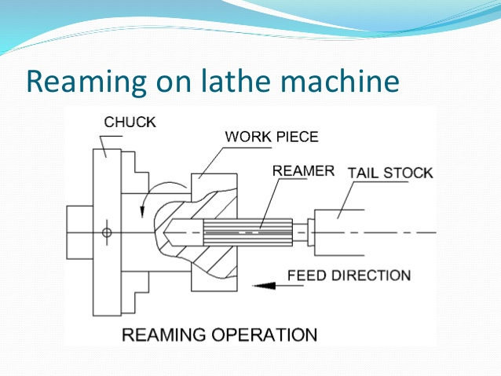

**Boring Operation:**

It is an operation which is employed for machining internal surfaces, hence also called as internal turning. Boring is done to enlarge the already drilled hole and bring them to the exact required size. Generally, a single point cutting tool is used for this purpose.

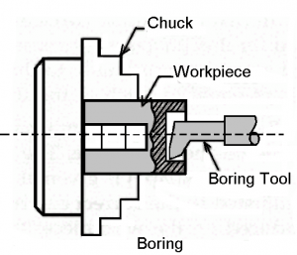

**Knurling**

Knurling is the process of embossing a diamond shaped pattern on the surface of the workpiece. The knurling tool holder has one or two hardened steel rollers with edges of required pattern. The tool holder is pressed against the rotating work. The rollers emboss the required pattern. The tool holder is fed automatically to the required length. Knurls are available in coarse, medium and fine pitches. The patterns may be straight, inclined or diamond shaped.

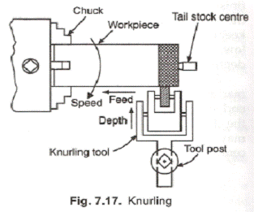

**Thread cutting**

Thread cutting is one of the most important operations performed in a lathe. The process of thread cutting is to produce a helical groove on a cylindrical surface by feeding the tool longitudinally.

1. The job is revolved between centres or by a The longitudinal feed should be equal to the pitch of the thread to be cut per revolution of the work piece.
2. The carriage should be moved longitudinally obtaining feed through the leadscrew of the
3. A definite ratio between the longitudinal feed and rotation of the headstock spindle should be found Suitable gears with required number of teeth should be mounted on the spindle and the leadscrew.
4. A proper thread cutting tool is selected according to the shape of the It is mounted on the toolpost with its cutting edge at the lathe axis and perpendicular to the axis of the work.
5. The position of the tumbler gears are adjusted according to the type of the thread (right hand or left hand).
6. Suitable spindle speed is selected and it is obtained through back
7. Half nut lever is engaged at the right point as indicated by the thread chasing
8. Depth of cut is set suitably to allow the tool to make a light cut on the
9. When the cut is made for the required length, the half nut lever is The carriage is brought back to its original position and the above procedure is repeated until the required depth of the thread is achieved.
10. After the process of thread cutting is over, the thread is checked by suitable gauges.

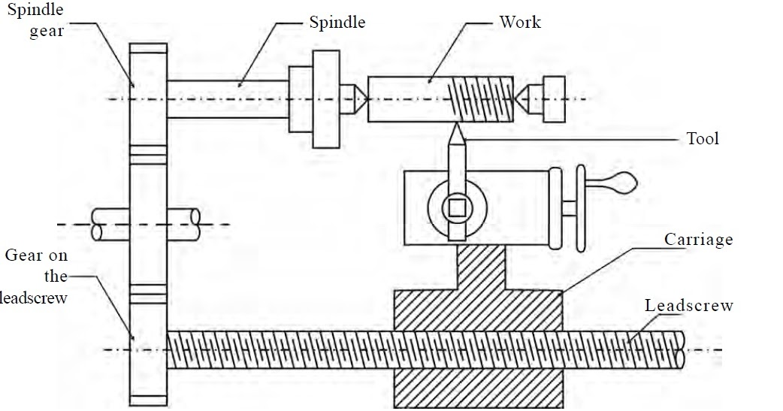

**Chamfering**

Chamfering is the operation of bevelling the extreme end of the workpiece. The form tool used for taper turning may be used for this purpose. Chamfering is an essential operation after thread cutting so that the nut may pass freely on the threaded workpiece.

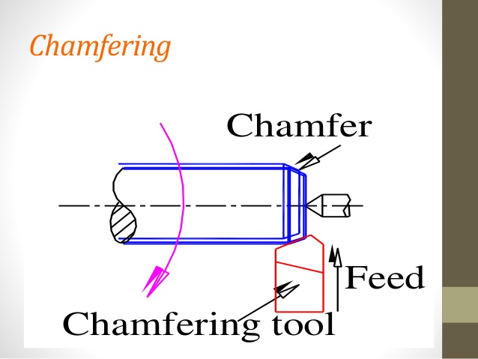

**Grooving**

Grooving is the process of cutting a narrow goove on the cylindrical surface of the workpiece. It is often done at end of a thread or adjacent to a shoulder to leave a small margin. The groove may be square, radial or bevelled in shape.

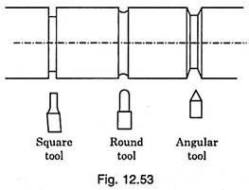

**Forming**

Forming is a process of turning a convex, concave or any irregular shape. For turning a small length formed surface, a forming tool having cutting edges conforming to the shape required is fed straight into the work.

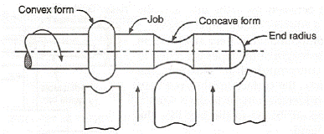

Selection Process of Materials:

1. Frame

Options available:

1. Mild Steel
2. Stainless Steel
3. Aluminium

The frame is the main structure of the project where the different parts are attached. The main function of the frame is support the main assembly and transfer of the load.

As the mild steel is easily available in the local market, and it can be machined according to use we used the mild steel for the manufacturing of the frame.

Mechanical Properties of Mild Steel:

Max Stress 400-560 n/mm2

Yield Stress 300-440 n/mm2 Min

0.2% Proof Stress 280-420 n/mm2 Min

Elongation 10-14% Min

Force Acting on the Frame:

* Weight of the components
* Force due to braking and acceleration

1. Seed Feeder:

Made up of Alumnium

1. Motor :

We are taking electrical components such that it can operate on 12V. As the 12V supply battery can be small and efficient to take load of the whole circuit.

12V DC Motor with 30RPM is used to drive the vehicle.

1. Wheels :

We are using wheels made up of Plastic and Rubber.

1. Water Tank and Pump :

12V DC pump operated water tank is used

**Working**

This multipurpose agro machine is wireless remote operated & designed and fabricated as a multipurpose equipment which is used for agricultural processes like ploughing, sowing seeds and sprinkling water. This machine works in both directions when it is pushed forward it ploughs the field with the help of plough. The height of the plough can be adjusted, with the help of screw arrangement and the seed feeder is mounted directly to the motor. The motor rotates and the shaft attached to it has holes. The motor is directly attached to the shaft with holes. When we push the agriculture machine in a backward direction, we can pick the plough up from the ground and the pump which is attached to the front shaft will start pumping the water from the tank and it will sprinkle water over the field.

**ARGICULTURAL EQUIPMENT**

**Objective of Our Project**

The purpose of this project is to provide farmer with multipurpose equipment which implements all the scientific farming specifications and technology to get maximum yield and good quality crops by reducing investment and number of labor.

There are many tractor powered equipment which are suitable and economical only for more than 5 acres of land. There are many hand pulled equipments which are only suitable for gardening purpose. Our objective of making animal powered equipment is suitable for 1 acre to 3 acres of land it is both economical and modernized with scientific methods. Majority of the

Indian formers are the land owners of 1 to 3 acres. Hence it is most suitable for Indian economy and farming techniques.

Factors That Influenced Design and Fabrication Of Our Equipment

* Scientific farming methods
* Precision farming
* Acceptance for all types of seed to seed farming
* Fool proofing
* Portability of the equipment: our equipment is completely flexible for easy assembly and disassembly.
* Low cost

**Advantages**

* low cost and more efficient
* energy efficient and eco-friendly
* better result than manual system
* works at much cheaper price

**Conclusion**

The multipurpose agricultural robot gives an advance method to sow, plow and spray water with minimum man power and labor making it an efficient vehicle. The machine will cultivate the farm by considering particular rows and specific column at fixed distance depending on crop.

**Reference**

1. Simon Blackmore, Bill Stout, Maohua Wang, Boris Runov (2005), Robotic agriculture – The future of agriculture mechanism, Agro Technology, the royal veterinary and agriculture University.

2. Agricultural Census: All India report on number and area of operational holdings. Agricultural census division, Department of agriculture and co-oeration, Ministry of Agricluture, Government of India 2014.

3. R. Eaton, R. Eaton, J. Katupitiya, S.D. Pathirana (2008), Autonomous farming: Modeling and control of agricultural machinery in a unified framework,15th international conference on mechatronics and machine vision in practice, NewZealand.

4. R. Eaton, R. Eaton, J. Katupitiya, S D Pathirana (2008), “Autonomous farming: Modeling and control of agricultural machinery in a unified framework

5. Akhila Gollakota, "A Multipurpose Agricultural Robot ", Birla Institute of Technology and Science, Hyderabad Campus

6. Vishnu Prakash K, Sathish Kumar V, Venkatesh P, Chandran A (2016), “DESIGN AND FABRICATION OF MULTIPURPOSE AGRICULTURAL ROBOT”, International Journal of Advanced Science and Engineering Research